Brief outline of the route of the old Town brook, that runs from Trinity via Town Mills and out to Sea.

As can be seen in the attached Town plan from 1910, the Town brook runs South from Trinty, and through Town Mills.
It then crosses Sprinfield Road near Le Geyt Road, and continues southerly and parallel running to the right of Janvrin Road, and through part of the new Springfield School playground (formally Janvrin School)
It then continues south, crosses St.Marks Road and Stopford Road, runs across the old Gas works site (formally meadows) and at tunnel Street it splits into two.
The Easterly section continues thus:-
Across Simon Place, continues south between Ann Street and St.Saviours Road, then veers westerly and crosses Ann Street. It then cuts across the bottom of Wesley Street, crosses Hilary Street and follows a westerly route along Hilgrove Street.
It then crosses Bath Street and Halket Street, veers north westerly a little and crosses Halkett Place, then continues westerly across Don Street, New Street and up to the rear of Hue Street.
It then sweeps around in a semi-circle at Charing Cross before heading south easterly behind Broad Street and takes a route under the General Post Office. From there it continues south easterly behind Broad Street, crosses Conway Street and goes down Cross Street.
It then runs in a south westerly direction still between Hope Street and Mulcaster Street, before exiting to the sea at the Weighbridge.

The North Westerly section after the split at Tunnel Street, follows a more direct route, and from Tunnel Street, it heads south near the junction with Gas Lane, and crosses Belmont Road, Belmont Place and Ann Place before turning west and down Phillips Street. (Note. At this junction there is also a spur or loop with runs westerly along Charles Street where upon it re-joins the main section at the junction of Charles Street and Bath Street)
From there it continues in a westerly direction along Minden Place and Burrard Street and into Union Street, where it heads south for a short distance (between New Street and Dumaresq Street), then westerly again across Dumaresq Street and Hue Street.
It then crosses near Charing Cross, but follows a route (below the edge) of the Town Hall, then continues westerly behind Seaton Place, before turning northerly for a short distance, and then finally joining the top half of Gloucester Street. From there it continues south down Gloucester Street until emerging at the sea wall.

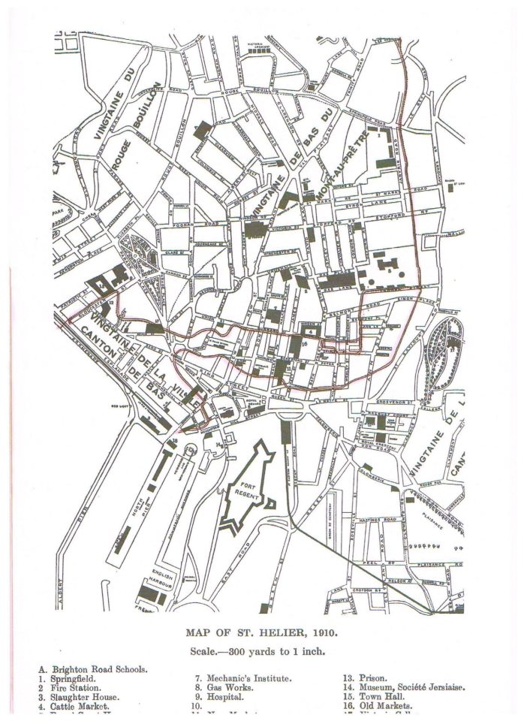
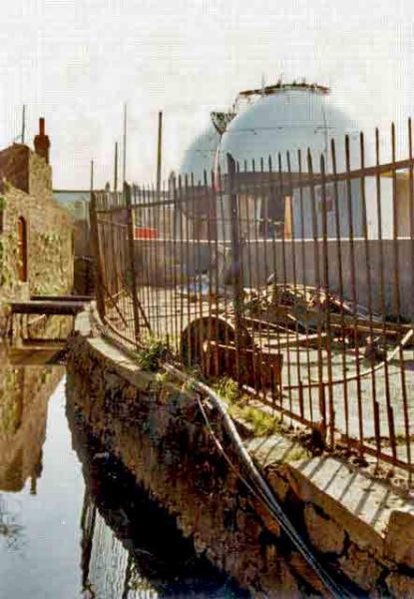
The Brook as it passes through the Gas Works site. C.1970
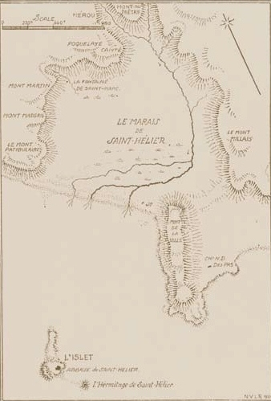 The Godfray map showing the old streams or Town brook.
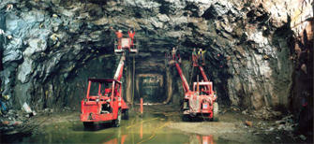
Work on the Cavern, an underground storage facility to collect excess rainwater located underneath Route de Fort area.

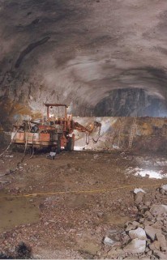 Geo Design picture of the Cavern work in progress.
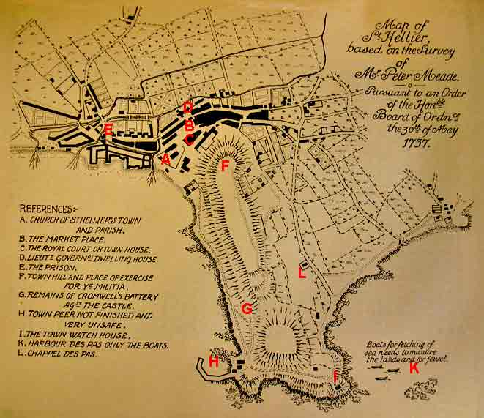
Meade’s map of 1737, showing the brooks two routes and the town outfalls.

